
Richard Bangs’ Adventures with Purpose
Egypt: Quest for the Lord of the Nile

Photos and captions:
High resolution JPG files of the photos below may be downloaded from www.AdventuresWithPurpose.tv/presskit. Photo files and captions are also on the enclosed press kit CD.
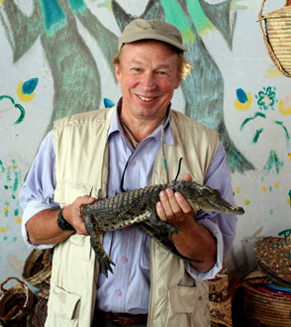
Richard Bangs holds a baby crocodile liberated from a cage in a Nubian village on the Nile River in Egypt. His one-hour documentary special “Egypt: Quest for the Lord of the Nile” tells the tale of a civilization inextricably bound to the waters of the Nile River and its creatures. From Alexandria to Cairo, from the Great Pyramids at Giza, to the Valley of the Kings, Richard explores the way the river and its fearsome Lord molded a society. Further upstream still, Bangs visits a temple at Kom Ombo dedicated to Sobek—the Crocodile God—and seeks the beast himself in the waters of Lake Nasser. Richard Bangs is often called the father of modern adventure travel. Leader of 35 first descents of rivers around the globe, a mountain climber and renowned author, Richard brings a lifetime of experience to Adventures with Purpose.

Richard Bangs’ Adventures with Purpose is produced by Small World Productions of Seattle and co-produced by KCTS/Seattle and Richard Bangs Productions of Marina del Rey, California. American Public Television distributes this award-winning documentary in HDTV and standard definition “letterboxed” formats. Production and distribution of the special is supported in part by Exofficio Travel Apparel.

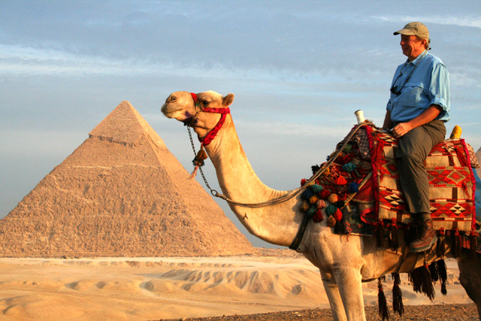
On camel back, Richard Bangs visits the Great Pyramids of Giza near Cairo, Egypt, before sailing up the Nile River to the Valley of the Kings, Kom Ombo, and Lake Nasser in his “Quest for the Lord of the Nile” through Egyptian history. Richard Bangs is host and co-executive producer for Adventures with Purpose, an award-winning one-hour documentary special from American Public Television. Bangs, a renowned modern explorer, has published more than 1000 magazine articles, 16 books, a score of documentaries and several CD-ROMs; and has lectured at the Smithsonian, the National Geographic Society, the Explorers Club and many other notable venues. He writes a semi-regular feature with the New York Times.

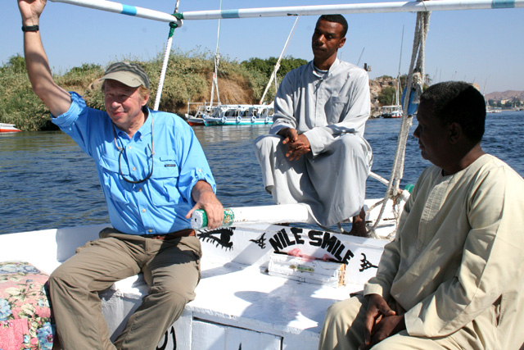
Renowned writer and adventurer Richard Bangs joins two Nile River boatmen sailing up river aboard a traditional Egyptian felucca riverboat. In “Quest for the Lord of the Nile” a new, one-hour American Public Television special, Bangs explores the Nile from Alexandria to Cairo, from the Great Pyramids of Giza to the Valley of the Kings, and finally to Kom Ombo and Lake Nasser. Richard Bangs is often called the father of modern adventure travel. Leader of 35 first descents of rivers around the globe, a mountain climber and renowned author, Richard brings a lifetime of experience to Adventures with Purpose. Richard Bangs’ Adventures with Purpose is produced by Small World Productions of Seattle and co-produced by KCTS/Seattle and Richard Bangs Productions of Marina del Rey, California. APT of Boston distributes this award-winning documentary to more than 250 public staions nationally.

Small World Productions
140 Lakeside Ave. Suite 200
Seattle, WA 98122

